

**Faculty of engineering - Shoubra**

**Benha University**

# Research Article / Research Project / Literature Review

in fulfillment of the requirements of

|  |  |
| --- | --- |
| **Department** | **Engineering Mathematics and Physics** |
| **Division** | **-------------** |
| **Academic Year** | **2019-2020 Preparatory** |
| **Course name** | **Computer** |
| **Course code** | **ECE001** |

## Title: -

**Build a website on recent computer engineering topics (Artificial Intelligence)**

By:

|  |  |  |  |
| --- | --- | --- | --- |
|  | Name | Edu mail | B.N |
| 1 | **اسراء سعيد علي علي حجر** | **esraa195182@feng.bu.edu.eg** | **170** |

**Approved by:**

|  |  |
| --- | --- |
| Examiners committee | Signature |
| Dr.Ahmed Bayoumi |  |
| Dr.Shady Elmashad |  |
| Dr. Abdelhamid Attaby |  |
|  |  |
|  |  |

**Name:** Esraa Said Ali Ali.  
**B.N:** 170  
**Date:** 28/5 **Topic:** Artificial Intelligence.   
**GitHub-link:**   
  
**Application Brief:**   
Artificial Intelligence refers to the simulation of human intelligence in machines which are programed to think like humans.  
When people hear the term of artificial intelligence the first thing they usually think of is robots, but that is wrong.  
AI is based on the principle that human intelligence can be defined in a way that a machine can easily mimic it and execute tasks, from the most simple to those that are even more complex.  
The goals of AI include learning, reasoning and perception.  
There are two types of AI: narrow AI & General AI.  
Although artificial intelligence has a strong science fiction connotation, AI forms a vital branch of computer science which deals with intelligence behavior, learning and adaption in machines.  
AI is concerned with producing machines to automate tasks which require intelligent behavior such as control, planning and scheduling.  
It has become a scientific discipline which is focused on proving solutions to real life problems.  
AI systems are now used in medicine, engineering, economics and the military.

**:**

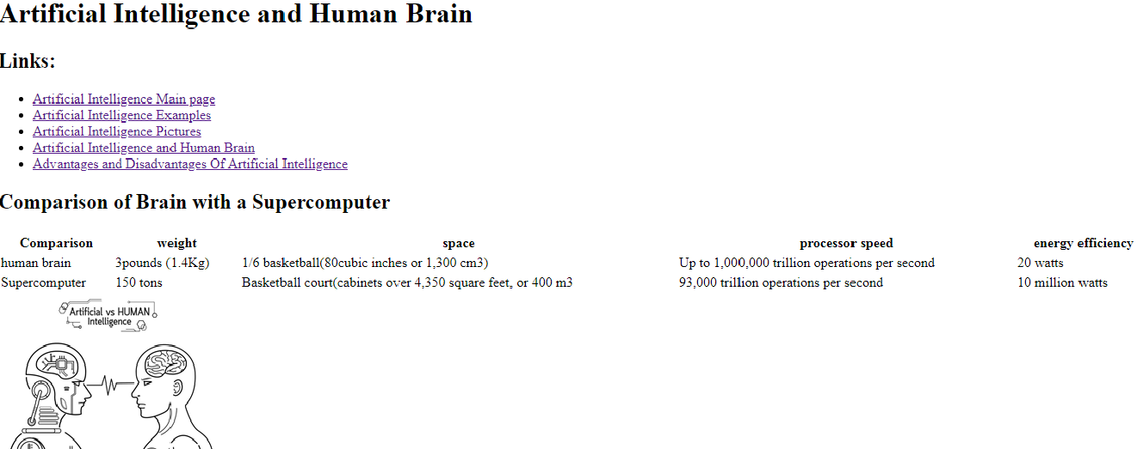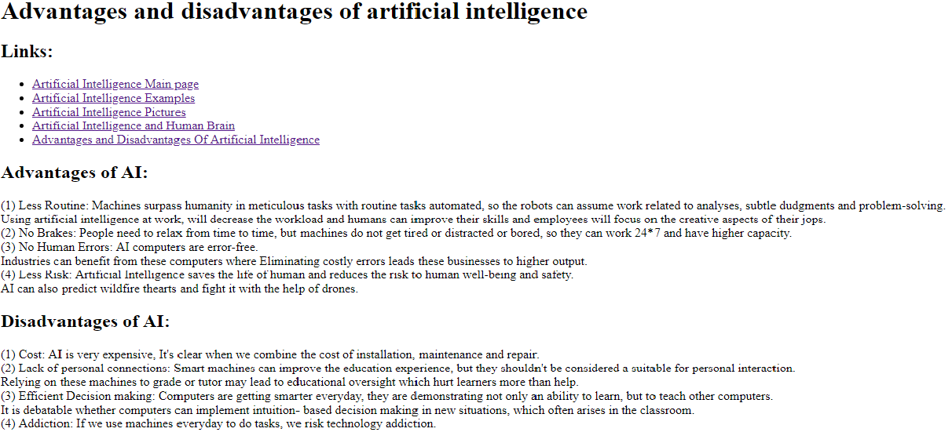**Screenshots:**

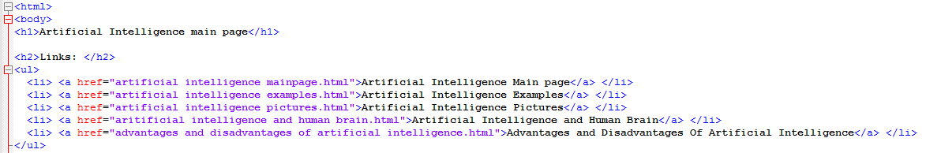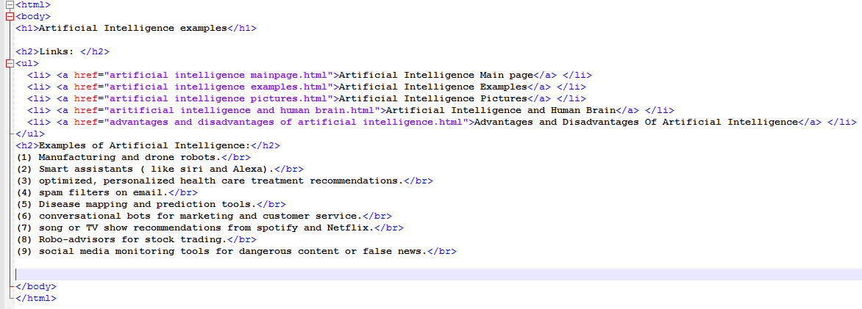**Source Code:**

**References:**1) <https://builtin.com/artificial-intelligence?fbclid=IwAR0VRpHtfnOqia02bYk0rr8qm_yLUVYatakB7zryFk-vwShJTDMS3xA9P2Y>   
  
2) <https://www.educba.com/artificial-intelligence-vs-human-intelligence/>  
  
3) <https://www.livetiles.nyc/pros-cons-artificial-intelligence-classroom?fbclid=IwAR2CxKG3PIvwqUcHCt2MDTwraJvTHAbhOGJEK23VjNSGVhKEXM-16_cDkJ0>   
  
4) <https://www.investopedia.com/terms/a/artificial-intelligence-ai.asp>